Component Library data import

Step 1: create file of required format
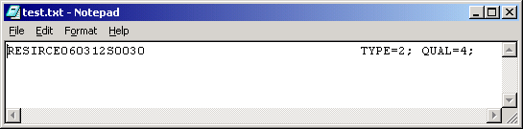

Step2: Open project, open Component Library
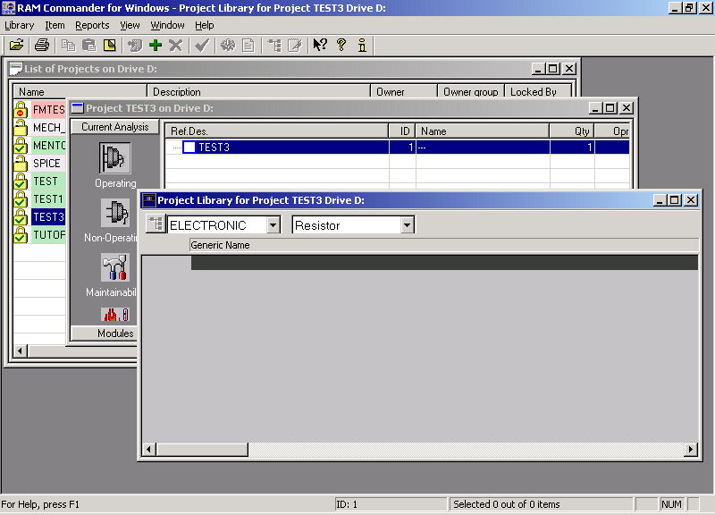

Step 3: Select “Import from ASCII”
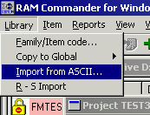

Step 4: Choose file
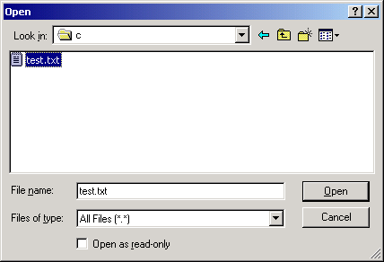

Step 5: take a look at imported data
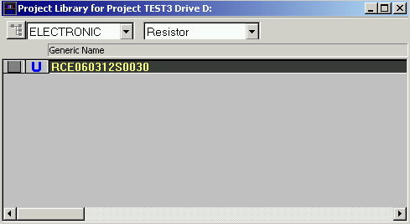

Step 6: Choose the resistor and double-click on it to open data screen:
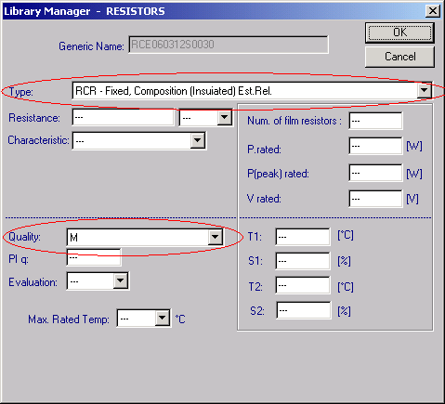
(Please note that the Quality and RCR type are imported).

